Metsä Board’s transformation to a paperboard company

Background
During years 1995–2001, Metsä Board (previously M-Real) acquired several production units around Europe and substantially increased its exposure in paper manufacturing especially on coated and uncoated fine paper. At highest, Metsä Board’s paper production capacity totalled 5.5 million tonnes per annum. Due to the many acquisitions, the company’s financial position was strained: balance sheet was heavy and interest-bearing net debt amounted to over EUR 3 billion.

The demand of printing and writing papers started declining in the USA around the years 2000–2001 – at the same time when Metsä Board was heavily increasing its paper production capacity. Later, many of these acquisitions turned out to be unsuccessful.

Mr. Kari Jordan to become Chairman of Metsä Board

Mr. Kari Jordan was appointed to the CEO of Metsäliitto Cooperative, the biggest owner of Metsä Board Corporation as of 1 January 2005. He was also appointed as President and CEO of Metsä Group as of 1 January 2006. He assumed the Chairman’s position at Metsä Board in the annual shareholders’ meeting in spring 2005.

In 2005, despite numerous recent acquisitions, Metsä Board’s Board of Directors started actions to turn around the company’s negative development. The decision to exit from paper manufacturing was based on a thorough analysis of the European paper market and the assumption that a significant decline in the demand of various paper grades will most likely happen also in Europe. This assumption turned out to be correct: during 2005–2014, the demand for printing and writing papers in Europe has declined by approximately 30–35 per cent.

Transformation starts
When Metsä Board’s structural change was started under Mr Jordan’s chairmanship in 2005, paper businesses represented 80 per cent of the company’s sales. The main target was to decrease the company’s exposure in paper manufacturing. Metsä Board launched a program which included restructuring measures, divestments and closures of mills. Furthermore, the company announced its new focus on fresh forest fibre paperboards.

The biggest divestments included the sale of paper merchant business, Map Merchants, in July 2007 and the divestment of Graphic Papers business area including four paper mills to Sappi in December 2008. In 2009, M-real (Metsä Board) and pulp manufacturer Metsä-Botnia’s other owners Metsäliitto Cooperative and UPM-Kymmene restructured the ownership of Metsä-Botnia, i.e. the Finnish pulp company ended in the books of Metsäliitto Cooperative and Metsä Board and the sale of Metsä-Botnia's Uruguayan operations to UPM.

In addition to these, several other mill divestments and paper machine closures were completed during 2005–2011. The remaining paper capacity of approximately 640,000 tonnes will mostly be discontinued during 2015.

From restructuring to development investments
In 2011 after heavy rationalisation phase, Metsä Board started a paperboard business investment programme. That included the expansion of folding boxboard capacity in total of 150,000 tonnes thru bottleneck investments in Simpele, Äänekoski and Kyröskoski and the renewal of Kemi mill's coating operations. In Kemi, investments focused more on product quality.

In December 2014, Metsä Board announced new measures to complete its transformation into a leading paperboard company. Paper production at Husum mill in Sweden will be ramped down mainly in 2015. With the announced investment of EUR 170 million in a new paperboard machine, the mill will be converted into one of the largest fresh forest fibre paperboard units in Europe. After completing the Husum investment, Metsä Board’s exit from the printing and writing paper business will be completed.

Good growth for paperboards globally
Packaging materials is a sizeable business globally, and it is expected to grow also in future driven by global trends such as urbanization, demographic changes, growing population as well as increasing awareness on environmental issues. In this context, the demand for fresh forest fibre paperboards is expected to grow strongly.

Leading market position
Today, Metsä Board is the leading producer of folding boxboard and white fresh forest fibre linerboard in Europe and a market pulp supplier. The company’s competitiveness is based on high-quality, renewable wood raw material that is 100 per cent traceable to sustainably managed, certified forests.

Metsä Board’s financial position is strong: profitability of the core businesses is top class in its field, balance sheet is healthy, net debt is on a good level and funding well balanced.

Key figures

EBIT % of sales
excl. non-recurring items

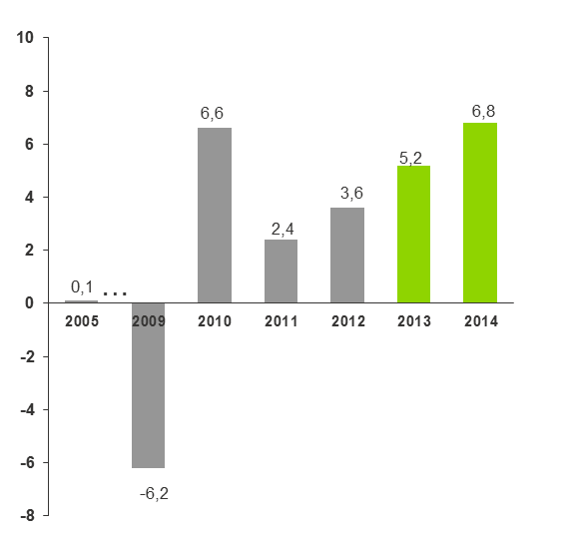

EBIT of key products*, % of sales

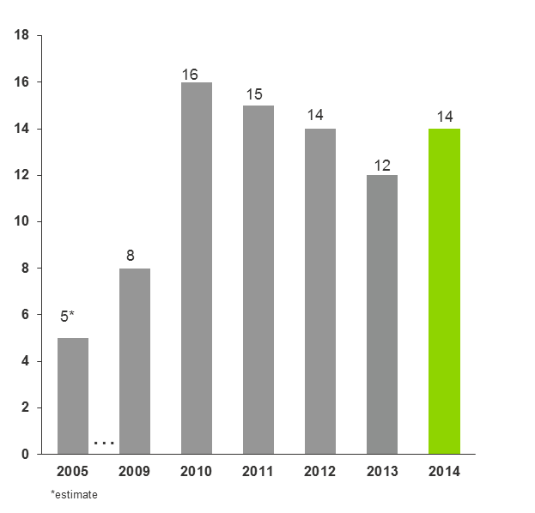

ROCE %, excl. non-recurring items

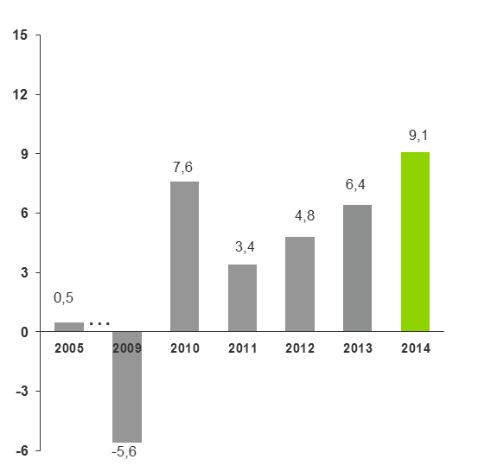

Net gearing

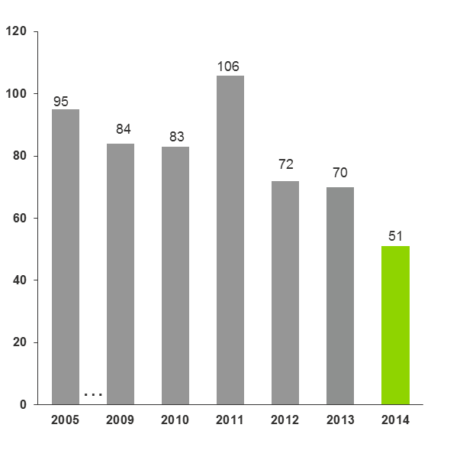

Net debt, EUR million

